

ARTIFICIAL INTELLIGENCE AND DATA SCIENCE

RENTIFY

**23ITR201 & FUNDAMENTALS OF WEB DESIGN**

**MINI PROJECT**

**REPORT**

**Name : Dhayanandham R**

**Roll No. : 717823I110**

**TABLE OF CONTENTS**

|  |  |
| --- | --- |
| **ABSTRACT** | **3** |
| **1. INTRODUCTION** | **4** |
| **1.1. Objective** | **5** |
| **2. REQUIREMENTS SPECIFICATION** |  |
| **2.1 Requirements** |  |
| **3. DETAILED DESIGN** |  |
| **4. PROJECT IMPLEMENTATION** |  |
| **5.CONCLUSION** |  |
|  |  |

# 

# ABSTRACT

This webpage has been meticulously crafted utilizing HTML and CSS technologies .The primary objective is to make a website that helps people find rental house ,pg home and apartment near their college and working place. So that makes peoples life easy and efficient.

Rentify is a cutting-edge web application designed to revolutionize the rental house search process. In a world where time is of the essence, Rentify offers users a seamless and efficient experience, enabling them to find their ideal rental property with ease. By leveraging advanced algorithms and user-centric design principles, Rentify delivers personalized recommendations and comprehensive property listings tailored to individual preferences.

Key features of Rentify include intuitive search functionalities, allowing users to filter properties based on location, price range, amenities, and property type. The platform utilizes geospatial technology to provide interactive maps, empowering users to explore neighborhoods and evaluate proximity to essential amenities such as schools, parks, and public transportation.

Rentify prioritizes accessibility and responsiveness, ensuring that the platform is accessible across a range of devices, including desktops, tablets, and smart phones. Data security and privacy are paramount, with robust encryption protocols in place to safeguard user information throughout the search process.

Through continuous refinement and user feedback, Rentify aims to become the premier destination for individuals seeking rental accommodations. By simplifying the search process and facilitating informed decision-making, Rentify empowers users to find their perfect rental home quickly and efficiently.

# INTRODUCTION

## Objective

Welcome to Rentify - your ultimate destination for finding the perfect rental

home tailored to your unique preferences and lifestyle. In a world where the search for rental accommodation can be overwhelming and time-consuming, Rentify is here to revolutionize the way you find your next living space.

**1.2 Working**

At Rentify, we understand that searching for a rental house can often feel like navigating a maze of listings, each with its own set of criteria and features. That's why we've embarked on a mission to develop a cutting-edge web application that simplifies the process and puts the power back in your hands.

Our platform is designed with you in mind, offering intuitive search functionalities and personalized recommendations to help you discover the ideal rental home with ease. Whether you're looking for a cozy studio apartment, a spacious family house, or anything in between, Rentify has you covered

With Rentify, you can say goodbye to endless scrolling and tedious filtering. Our advanced algorithms and user-friendly interface make it simple to narrow down your options based on location, price range, amenities, and more. Plus, our platform is continuously updated with the latest listings, ensuring that you have access to the most comprehensive selection of rental properties available.

But Rentify is more than just a search engine - it's a community of renters dedicated to making the process of finding a new home as seamless and stress-free as possible. With features such as user reviews, neighborhood guides, and interactive maps, Rentify provides you with all the information you need to make informed decisions about your next rental.

Join us on this exciting journey as we embark on the development of Rentify - the ultimate solution for finding your dream rental home. With Rentify, your next adventure in renting begins here.

# REQUIREMENTS SPECIFICATION

## Requirements

* One should known the basics of HTML
* One should know how to script a page using JAVASCRIPT
* One should know about Bootstrap
* Knowledge about creating forms
* Knowledge about inseating hyperlink
* External css file
* Internal css
* Inline css knowledge

# DETAILED DESIGN

* <HTML> IS CREATING FOR DOCUMENT IN BROWSER
* <HEAD> IS USED TO ENTER TITLE TAG AND USAGE OF INTERNAL CSS
* <STYLE> IS USED TO ENTER A INTERNAL CSS INSIDE THE HEAD
* <BODY> WHICH CONTAINS ALL ELEMENTS AND TAGS
* <P> THIS IS PARAGRAPH TAG USED TO TYPE AN PARAGRAPH AND SOME SENTENCE
* < DIV > DIV TAG IS USED TO SEPARATE ITEMS IN GRID
* CLASS=” USED TO COMBINE TAGS IN HTML FOR TOTAL
* CSS EXCUTION
* <FORM> USED TO CREATE THE REMARKS AND RATING FORM
* <FIELDSET> IS USED TO CONTAIN THE FORM IN GOOD MANER
* <INPUT> IS USED TO INPUT THE CONTENT
* <I FRAME > IS USED TO SHOW SOME SPACIAL CONTENT IN PARTICULAR AREA
* CSS- USED FOR DECORATION AND OTHERS
* <FIELDSET> USED TO SET A FORM IN TO A PARTICULAR BOX OR AREA AND OTHERS REQUIRED ATTRIBUTE - FOR SHOW A MESSAGE WITHOUT FILLING A FORM
* ERROE MESSAGE

# PROJECT IMPLEMENTATION

**Mainfile(Html)**

<!DOCTYPE html>

<html lang="en">

<head>

<meta charset="UTF-8">

<meta name="viewport" content="width=device-width, initial-scale=1.0">

<title>Rentify</title>

<link rel="stylesheet" href="project.css">

</head><body>

<header>

<h1> RENTIFY </h1>

</header>

<nav>

<ul>

<li><a href="file:///C:/Users/HP/Desktop/vijith/project.html">Home</a></li>

<li><a href="file:///C:/Users/HP/Desktop/vijith/about.html">House Details</a></li>

<li><a href="file:///C:/Users/HP/Desktop/vijith/login.html">Rent Now</a></li>

<li><a href="file:///C:/Users/HP/Desktop/vijith/contact.html">Contact</a></li>

</ul>

</nav>

<section class="hero">

<div class="container">

<h2>Welcome to Rentify</h2>

<p>Book your PGs,Apartmant and Houses around Tamilnadu easily and efficiently at low cost under your convience.Now!.</p>

<a href="file:///C:/Users/HP/Desktop/vijith/about.html"> <button class="btn">Get Started</button></a> </div>

</section>

</body>

</html>

**Main(css)**

body {

font-family: Arial, sans-serif;

background-image: url('./h3.jpg');

background-size: cover;

height: 100vh;

}

.container{

color: black;

max-width: 1200px;

padding: 0 20px;

}

header {

background-color: #333;

color: #fff;

padding: 15px;

text-align: center;

}

nav {

background-color: #444;

padding: 10px 0;

}

nav ul {

list-style-type: none;

margin: 0;

padding: 0;

text-align: center;

}

nav ul li {

display: inline;

margin-right: 20px;

}

nav ul li a {

color: #fff;

text-decoration: none;

}

.nav>a:hover{

background-color: #333;

border-radius: 10px;

color: #0e0202;

}

.hero {

text-align: center;

padding: 100px 0;

}

.hero h2 {

font-size: 36px;

margin-bottom: 20px;

}

.hero p {

font-size: 18px

.btn {

display: inline-block;

background-color: #333;

color: #fff;

padding: 10px 20px;

text-decoration: none;

border-radius: 5px;

}

.btn:hover {

background-color: #555;

box-shadow: 0 0 15px 5px #000000;

transform: scale(1.02);

}

.bottom{

background-color: #333;

color: #ffffff;

height:150px ;

}

#one{

text-align: center;

}

#two{

text-align: center;

}

#three{

text-align: center;

}

#four{

text-align:center

}

li>a:hover{

color: #000000;

background-color: #ffffff;

padding: 5px;

border-radius: 10px;

transition: 50ms;

}

**Login(Html)**

<!DOCTYPE html>

<html lang="en">

<head>

<meta charset="UTF-8">

<meta name="viewport" content="width=device-width, initial-scale=1.0">

<title>HOUSE RENTING</title>

<link rel="stylesheet" href="login.css">

</head>

<body>

<header>

<h1>Rent your House</h1>

</header>

<nav>

<ul>

<li><a href="file:///C:/Users/HP/Desktop/vijith/project.html">Home</a></li>

<li><a href="file:///C:/Users/HP/Desktop/vijith/about.html">About</a></li>

<li><a href="file:///C:/Users/HP/Desktop/vijith/login.html">Book Now</a></li>

<li><a href="file:///C:/Users/HP/Desktop/vijith/contact.html">Contact</a></li>

</ul>

</nav>

<form class="hi">

<fieldset>

<h1>House code </h1>

<input type="text"> <br> <h1>PAY BOOKING FORM</h1>

<p>PLEASE FILL OUT THE DETAILS BELOW TO BOOK YOUR SERVICE</p>

<label>FULL NAME</label><br>

<input type="text"><br>

<label >EMAIL</label><br>

<input type="email"><br>

<p>we will send booking confrimation to your mail </p><br>

<label>CONTACT NUMBER</label><br>

<input type="number"><br>

<label>DATE</label><br>

<input type="date" id="date"/><br>

<label>TIME</label><br>

<input type="time" id="date" placeholder="hh:mm"/><br>

<input type="checkbox"><label >AGREED IF WHATEVER HAPPENS IN OUR TIME </label><br>

<label >PAYMENT </label>

<input type="number" value="$"><br>

<input class="btn" type="submit" value="submit">

</fieldset></form>

</body>

</html>

**Login(CSS)**

.hi{

text-align: center;

background-color: #4b6361;

height: auto;

font-family: Verdana, Geneva, Tahoma, sans-serif;

}

header {

background-color: #333;

color: #fff;

padding: 15px;

text-align: center;

}

nav {

background-color: #444;

padding: 10px 0;

}

nav ul {

list-style-type: none;

margin: 0;

padding: 0;

text-align: center;

}

nav ul li {

display: inline;

margin-right: 20px;

}

nav ul li a {

color: #fff;

text-decoration: none;

}

.nav>a:hover{

background-color: #333;

border-radius: 10px;

color: #ffffff;

}

li>a:hover{

color: #000000;

background-color: #ffffff;

padding: 5px;

border-radius: 10px;

transition: 50ms;

}

**About(Html)**

<!DOCTYPE html>

<html lang="en">

<head>

<meta charset="UTF-8">

<meta name="viewport" content="width=device-width, initial-scale=1.0">

<script src="https://kit.fontawesome.com/490c275fc9.js" crossorigin="anonymous"></script>

<title>TURFHOUSE</title>

<link rel="stylesheet" href="about.css">

<style>

</style>

</head>

<body><header>

<h1>BOOKING</h1>

</header>

<nav>

<ul>

<li><a href="file:///C:/Users/HP/Desktop/vijith/project.html">Home</a></li>

<li><a href="file:///C:/Users/HP/Desktop/vijith/about.html">About</a></li>

<li><a href="file:///C:/Users/HP/Desktop/vijith/login.html">Book Now</a></li>

<li><a href="file:///C:/Users/HP/Desktop/vijith/contact.html">Contact</a></li>

</ul>

</nav>

<h1 class="head">Choose your space</h1><div>

<div class="grid">

<div id="a1">

<div class="viji"> <img class="happy" src="./h4.jpg" alt="">

<h2>Shree Residency</h2>

</div>

<div ><h3>Location--MVM Nagar</h3>

<h3> Dindigul ,TamilNadu</h3><div><i class="fa-solid fa-star gi"></i><i class="fa-solid fa-star gi"></i><i class="fa-solid fa-star gi"></i></div>

</div>

</div>

<div id="a1">

<div class="viji"> <img class="happy" src="./h5.jpg" alt="">

<h2>Dhaya Nivas</h2>

</div>

<div><h3>Location--Dhaya nivas,Vijayamadavan nagar</h3>

<h3> Dindigul,Tamilnadu</h3><div> <i class="fa-solid fa-star gi"></i> <i class="fa-solid fa-star gi"></i><i class="fa-solid fa-star gi"></i><i class="fa-solid fa-star gi"></i></div>

</div>

</div>

<div id="a1">

<div class="viji"> <img class="happy" src="./h6.jpg" alt="">

<h2>Bunty Booking</h2>

</div>

<div><h3>Location--46,Karpagam University opp</h3>

<h3> Coimbature,Tamilnadu</h3>

<div> <i class="fa-solid fa-star gi"></i> <i class="fa-solid fa-star gi"></i> <i class="fa-solid fa-star gi"></i><i class="fa-solid fa-star gi"></i></div>

</div>

</div>

<br>

<div id="a1">

<div class="viji"> <img class="happy" src="./images.jpg" alt="">

<h2>Ranjith Resisdency</h2>

</div>

<div><h3>Location--28,Virat nagar</h3>

<h3> Coimbature,Tamilnadu</h3>

<div> <i class="fa-solid fa-star gi"></i> <i class="fa-solid fa-star gi"></i> <i class="fa-solid fa-star gi"></i><i class="fa-solid fa-star gi"></i></div>

</div>

</div>

<div id="a1">

<div class="viji"> <img class="happy" src="./h8.jpg" alt="">

<h2>Harry Homes</h2>

</div>

<div><h3>Location--2,omr street</h3>

<h3> Chennai,Tamilnadu</h3>

<div> <i class="fa-solid fa-star gi"></i> <i class="fa-solid fa-star gi"></i> <i class="fa-solid fa-star gi"></i><i class="fa-solid fa-star gi"></i></div>

</div>

</div>

<div id="a1">

<div class="viji"> <img class="happy" src="./h7.jpg" alt="">

<h2>Plant Resisdency</h2>

</div>

<div><h3>Location--28,Gandhi nagar</h3>

<h3> Madurai,Tamilnadu</h3>

<div> <i class="fa-solid fa-star gi"></i> <i class="fa-solid fa-star gi"></i> <i class="fa-solid fa-star gi"></i><i class="fa-solid fa-star gi"></i></div>

</div>

</div>

</div>

</body>

</html>

**About(CSS)**

header {

background-color: #333;

color: #fff;

padding: 15px;

text-align: center;

}

nav {

background-color: #444;

padding: 10px 0;

}

nav ul {

list-style-type: none;

margin: 0;

padding: 0;

text-align: center;

}

nav ul li {

display: inline;

margin-right: 20px;

}

nav ul li a {

color: #fff;

text-decoration: none;

}

.nav>a:hover{

background-color: #333;

border-radius: 10px;

color: #ffffff;

}

.head{

text-align: center;

color: black;

}

.happy{

height: 300px;

}

#a1{

margin: auto;

border: solid 2px black;

transition: all 0.1s ease 0s;

}

#a1:hover{

box-shadow: 0 0 15px 5px #000000;

transform: scale(1.02);

}

li>a:hover{

color: #000000;

background-color: #ffffff;

padding: 5px;

border-radius: 10px;

transition: 50ms;

}

.happy{

height: 250px;

}

.grid{

display:flex;

flex-wrap: wrap;

}

**Contact(Html)**

<!DOCTYPE html>

<html lang="en">

<head>

<meta charset="UTF-8">

<meta name="viewport" content="width=device-width, initial-scale=1.0">

<title>TURFHOUSE</title>

<link rel="stylesheet" href="contact.css">

</head>

<body>

<header>

<h1> RENTIFY </h1>

</header>

<nav>

<ul>

<li><a href="file:///C:/Users/HP/Desktop/vijith/project.html">Home</a></li>

<li><a href="file:///C:/Users/HP/Desktop/vijith/about.html">About</a></li>

<li><a href="file:///C:/Users/HP/Desktop/vijith/login.html">Book Now</a></li>

<li><a href="file:///C:/Users/HP/Desktop/vijith/contact.html">Contact</a></li>

</ul>

</nav><div class="vi">

<H1> FOR MORE DETAILS</H1>

<h3>Contact:9876543201</h3>

<h3>Instagram:rentify</h3>

<h3>Facebook:rentify4u</h3>

<h3>Email:rentify@gmail.in</h3>

</div></body>

</html>

**Contact(CSS)**

header {

background-color: #333;

color: #fff;

padding: 15px;

text-align: center;

}

nav {

background-color: #444;

padding: 5px 0;

}

nav ul {

list-style-type: none;

margin: 0;

padding: 0;

text-align: center;

}

nav ul li {

display: inline;

margin-right: 10px;

}

nav ul li a {

color: #fff;

text-decoration: none;

}

.nav>a:hover{

background-color: #333;

border-radius: 10px;

color: #ffffff;

}

.head{

text-align: center;

color: black;

}

li>a:hover{

color: #000000;

background-color: #ffffff;

padding: 5px;

border-radius: 10px;

transition: 50ms;

}

body{

text-align: center;

font-family: Verdana, Geneva, Tahoma, sans-serif;

}

.vi{

background-color: antiquewhite;

}

# CONCLUSION

# 

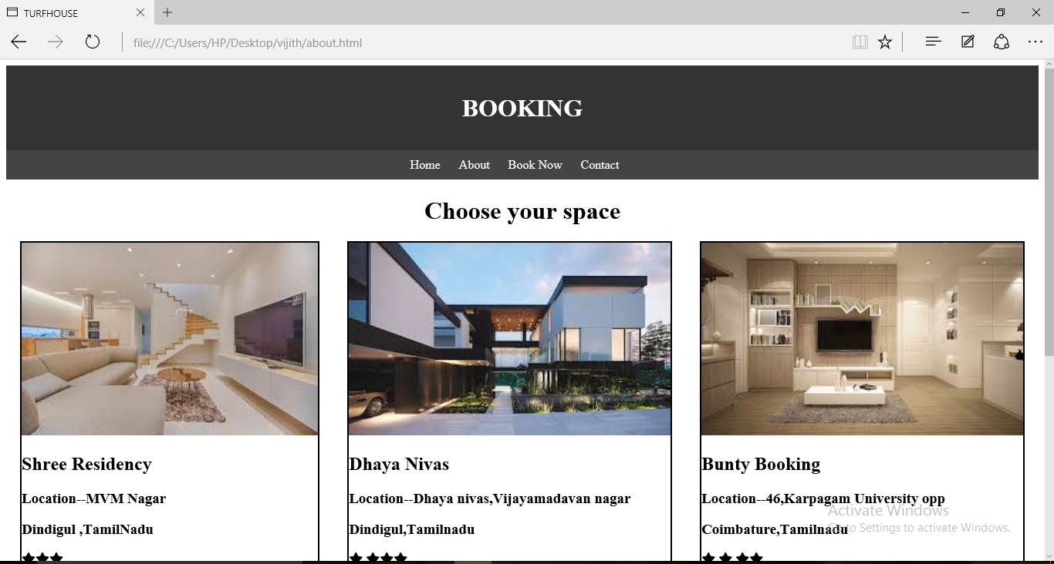

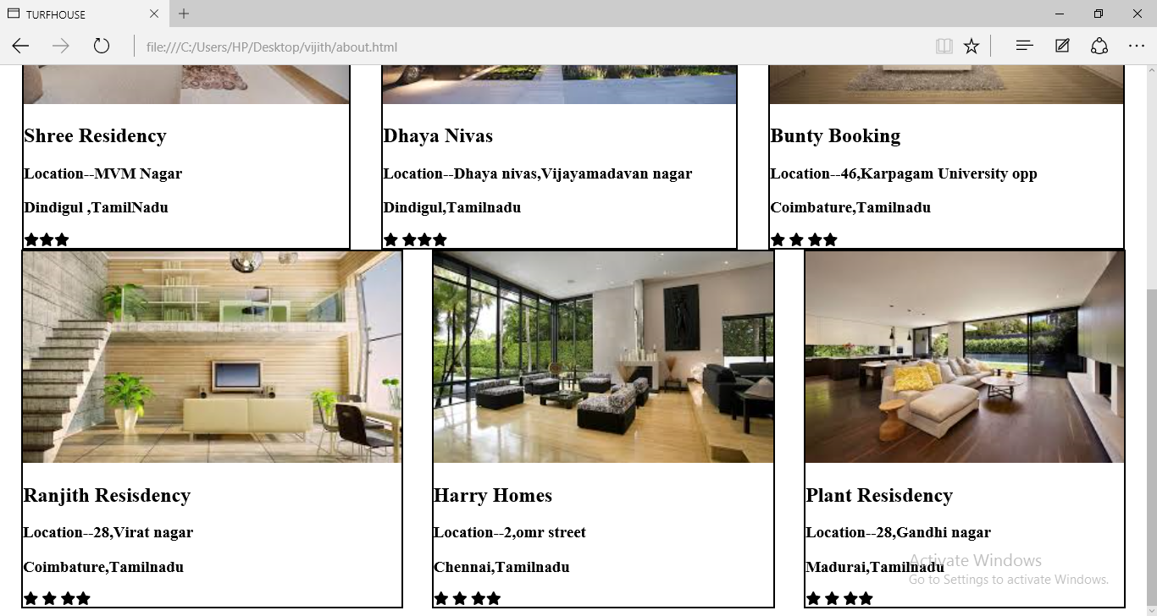

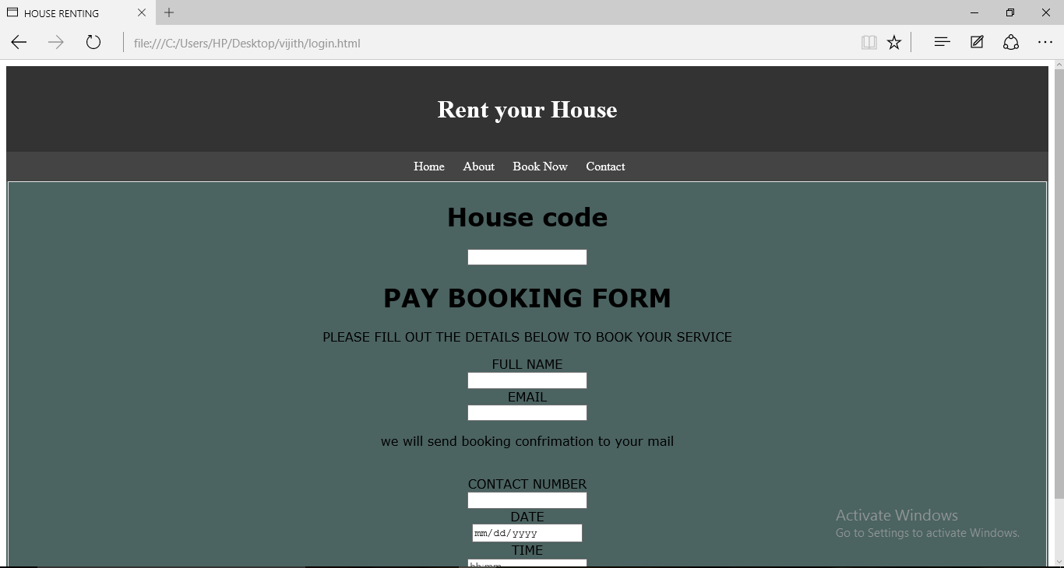

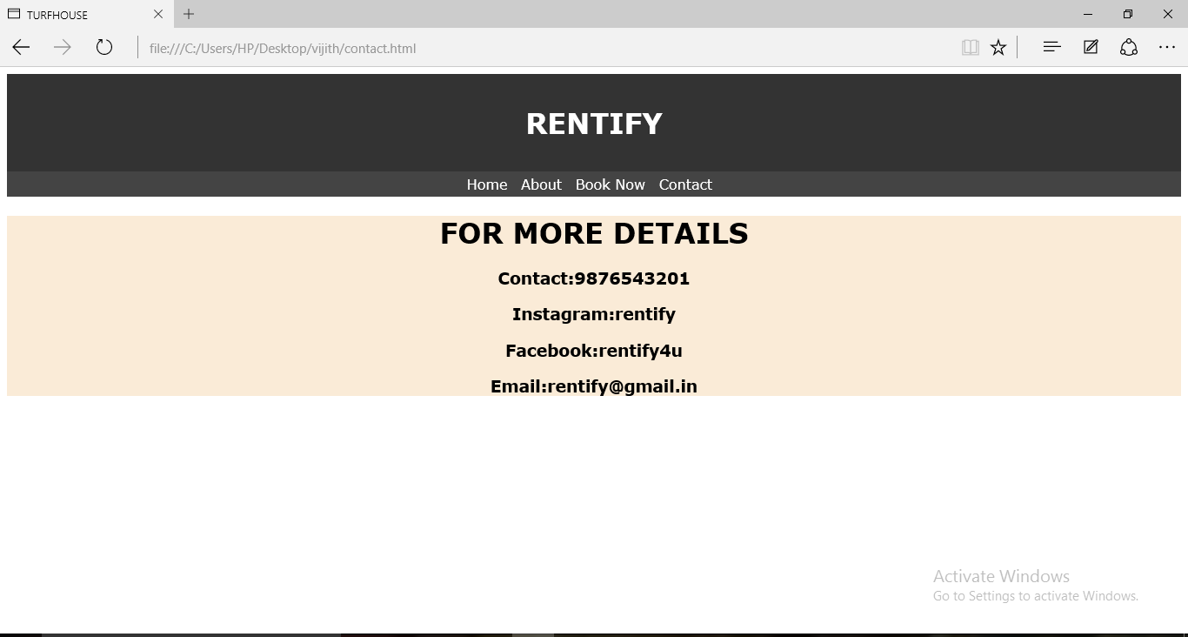

Thus,the webpage (Rentify) has been created successfully.